**Creation of tables (Daily Expenses)**

|  |  |
| --- | --- |
| Team id | LTVIP2025TMID29041 |
| Project Name | Calculating Family Expenses |
| College Name | Kandula Lakshumma Memorial College of Engineering for Women |
| course | Computer Science Engineering |

**1.Creation of Daily Expenses**

Record and manage everyday spending data in a structured format, enabling users to track daily financial activity, monitor patterns, and generate useful reports for budgeting or analysis

* Go to All > In the filter search for Tables > click on New.
* Enter the Details:
* Label : Daily Expenses
* Name : Auto-Populated
* Add Module to menu : Family Expenditure

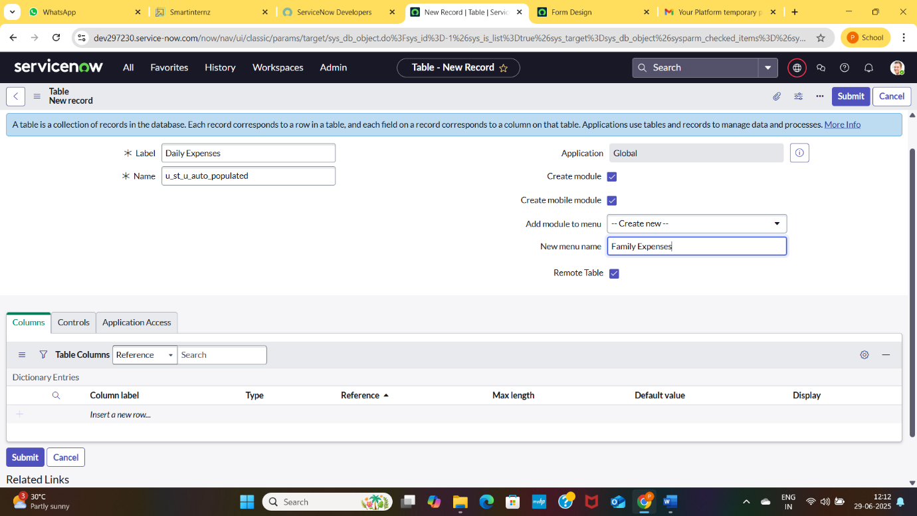

* Click on save